UI bug –

Bug Title: Misalignment of Close option for “ACCESS IS EVERYTHING” menu on home page .

Steps to Reproduce: Navigate to [www.topcoder.com](http://www.topcoder.com)

Actual Result: “ACCESS IS EVERYTHING” menu is seen on home page, with text centre aligned. However , the Close button is not aligned in the same line as the text.

Expected Result: Close button is centre aligned , like the text .

Screenshots or screencast URL: <URL of screenshots/screencast of the issue>

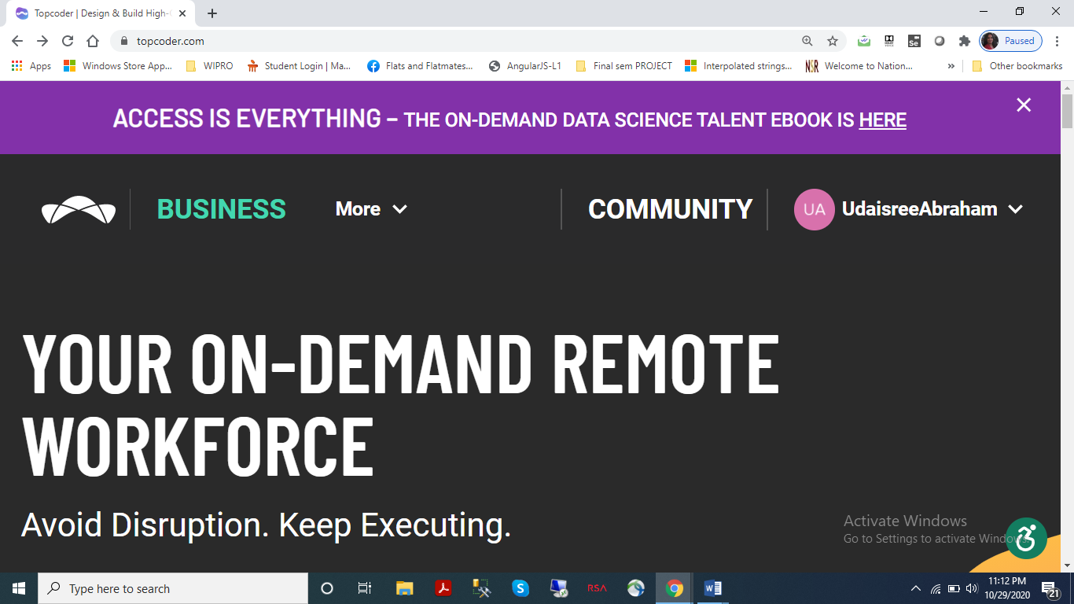

Device/OS/Browser Information: <Detailed device, OS and Browser information>

1. Device – HP Probook laptop

2. OS – Windows 10

3. Browser – Google chrome